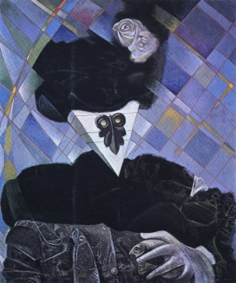
Euclide, Max Ernst, 1945 (www.les-mathematiciens.net)

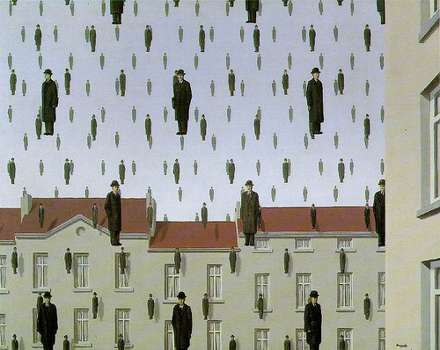
Golconde, René Margritte, 1953 (www.noselfcontrol.wordpress.com)

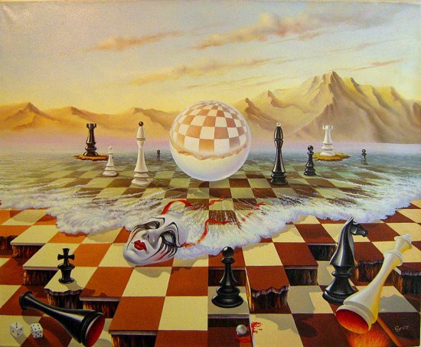
The fools rule the world, Gyuri Lohmuller, 2009 (www.foundmyself.com)

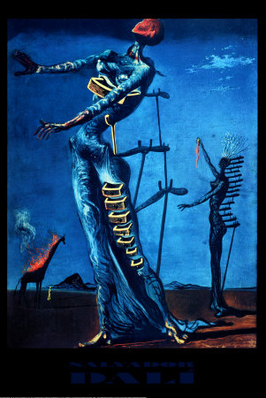
Girafe en feu, Dali, 1936-1937
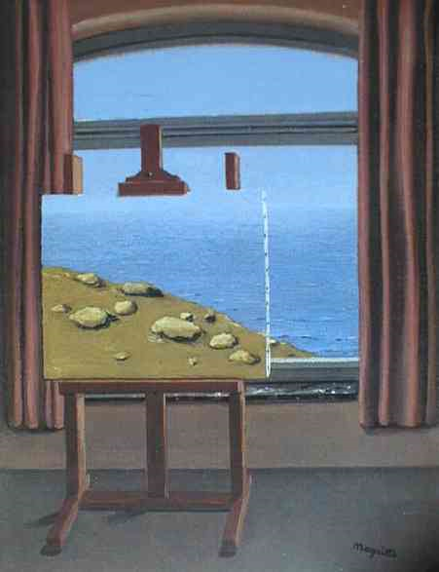
Margritte (www.google.fr ---- tableaux surréalistes)

